Press release
Bonn, 08/01/2026

EMBARGOED until 04:00 a.m. CET, 14/01/2025
Find additional resources HERE. (Password: GCH2025press)
The contents on this page will be updated until the embargo lifts
To register to attend the embargoed press conference (12th January), please follow this LINK by Friday 9th January

Copernicus: 2025 was the third hottest year on record

Copernicus data show that 2025 was the third warmest year on record, only marginally (0.01°C) cooler than 2023, and 0.13°C cooler than 2024 – the warmest year on record. The past 11 years have been the 11 warmest on record. Global temperatures from the past three years (2023-2025) averaged more than 1.5°C above the pre-industrial level (1850–1900). This marks the first time a three-year period has exceeded the 1.5°C limit. Air temperature over global land areas was second warmest, whilst the Antarctic saw its warmest annual temperature on record and the Arctic its 2nd warmest.

The findings are released today by the European Centre for Medium-Range Weather Forecasts (ECMWF), which operates the Copernicus Climate Change Service (C3S) and Copernicus Atmosphere Monitoring Service (CAMS) on behalf of the European Commission. The following organisations involved in global climate monitoring – ECMWF, NASA, NOAA, the UK Met Office, Berkeley Earth, and the World Meteorological Organisation (WMO) – have coordinated the release of their data.
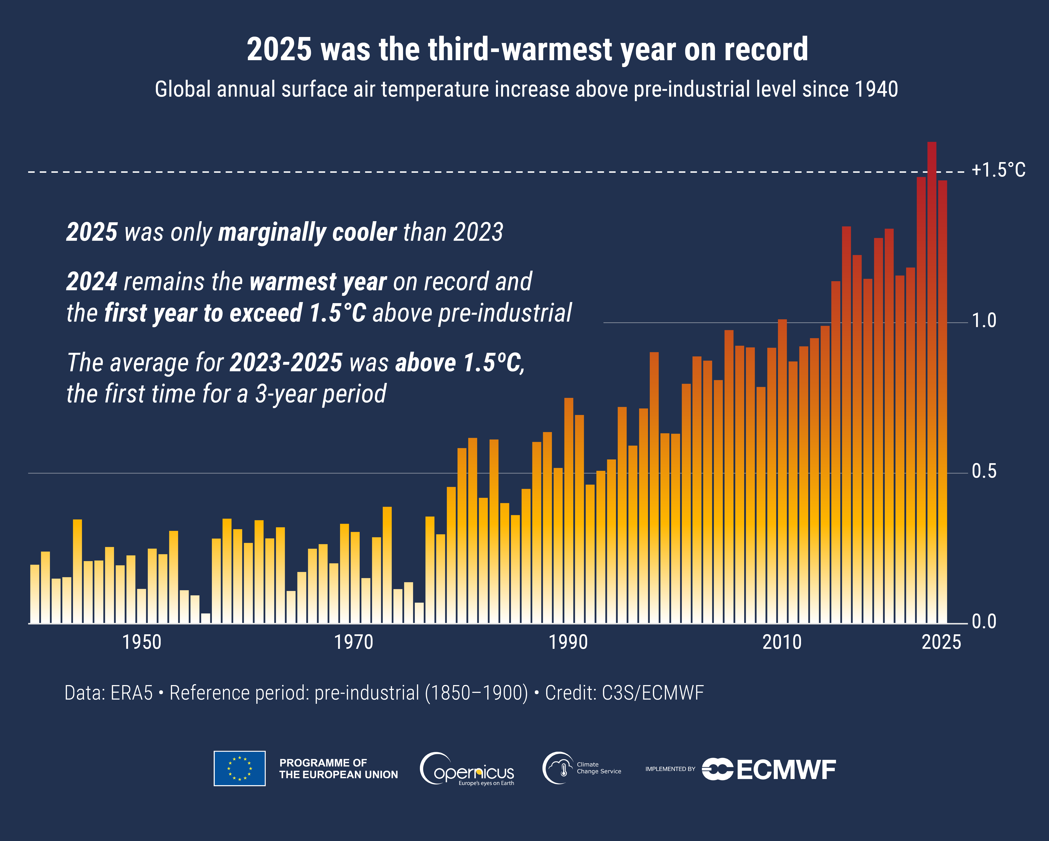
Global surface air temperature increase (ºC) above the average for the 1850–1900 designated pre-industrial reference period based on the ERA5 dataset, shown as annual averages since 1940. Credit: C3S/ECMWF.

In 2025, according to ERA5, the global surface air temperature was 1.47°C above the pre-industrial level, following 1.60°C in 2024, the warmest year on record. Utilising several methods, the current level of long-term global warming is estimated to be around 1.4°C above the pre-industrial level. Based on the current rate of warming, the Paris Agreement’s limit of 1.5°C for long-term global warming could be reached by the end of this decade – over a decade earlier than predicted based on the rate of warming at the time the agreement was signed.

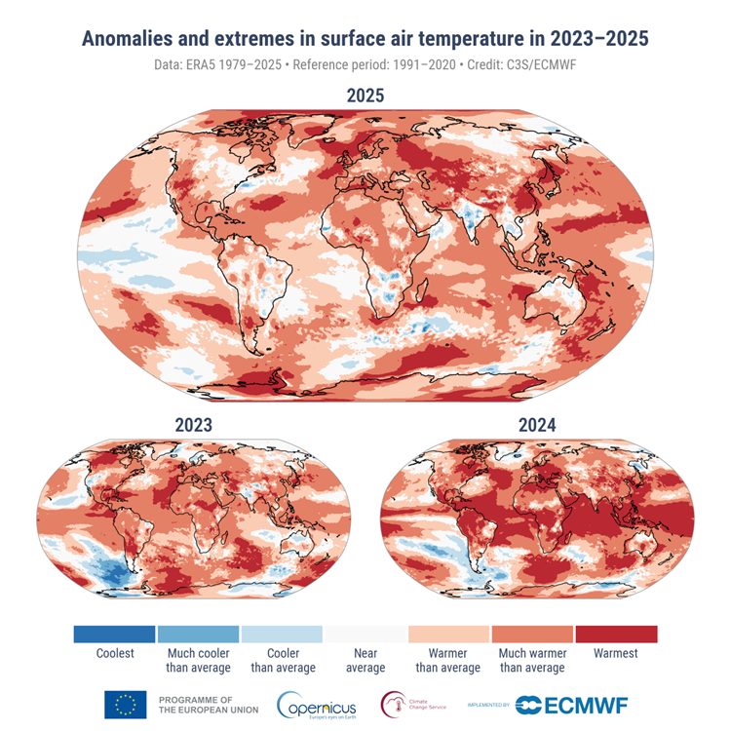
Anomalies and extremes in surface air temperature for 2025, 2023 and 2024. Colour categories refer to the percentiles of the temperature distributions for the 1991–2020 reference period. The extreme (“Coolest” and “Warmest”) categories are based on rankings for the period 1979–2025. Data source: ERA5. Credit: C3S/ECMWF.

The last three years 2023-2025 were exceptionally warm for two main reasons. The first is the build-up of greenhouse gases in the atmosphere, from continued emissions and reduced uptake of carbon dioxide by natural sinks. Secondly, sea-surface temperatures reached exceptionally high levels across the ocean, associated with an El Niño event and other ocean variability factors, amplified by climate change. Additional factors include changes in the amounts of aerosols and low cloud and variations in atmospheric circulation.

As in 2023 and 2024, a significant fraction of the globe was much warmer than average in 2025. Air and sea surface temperatures in the tropics were lower than in 2023 and 2024, yet still much above average in many areas outside of the tropics. The lower tropical temperatures compared to 2023-2024 were partly due to the persistence of near-average (‘ENSO-neutral’) or weak La Niña conditions in the equatorial Pacific throughout 2025. The higher temperatures of the two previous years were partially influenced by a strong El Niño event. El Niño tends to have a warming effect on global temperatures, superimposed on long-term human-caused global warming, whereas La Niña tends to have the opposite effect. Temperatures over the tropical Atlantic and Indian Ocean were also less extreme in 2025 than in 2024.

Higher temperatures in the polar regions partly offset the lower temperatures observed in tropical regions during 2025. The annual average temperatures reached their highest value on record in the Antarctic, and their second-highest in the Arctic². Record-high annual temperatures were also observed in several other regions, notably in the northwestern and southwestern Pacific, the northeastern Atlantic, far eastern and north-western Europe and central Asia.

Florian Pappenberger, ECMWF Director-General, comments: “This report confirms that Europe and the world are in the warmest decade on record and that the European Commission’s investment in Copernicus continues to be critical. As an international organisation serving 35 nations, ECMWF provides the world leading science for informed decisions to be made, and ultimately action taken, to adapt to climate change, because every year and every degree counts. Preparedness and prevention remain possible but only when action is guided by robust, scientific evidence”.

Mauro Facchini, Head of Earth Observation at the Directorate General for Defence Industry and Space, European Commission, comments: "Copernicus was established to provide policymakers, businesses, academics, and citizens in Europe and across the world with trusted, independent climate and atmospheric insights to inform decisions. Today’s results show just how vital that mission has become. Exceeding a three-year average of 1.5°C above pre-industrial levels is a milestone none of us wished to reach, yet it reinforces the importance of Europe’s leadership in climate monitoring to inform both mitigation and adaptation. We expect Copernicus to play an important role in implementing tailored new tools for European climate resilience and risk management.”

In 2025, half of the global land area experienced more days than average with at least strong heat stress – defined as feels-like temperature of 32°C or above. Heat stress is recognised by the WHO as the leading cause of global weather-related deaths. In areas with dry and often windy conditions, high temperatures also contributed to the spread and intensification of exceptional wildfires, which produce carbon, toxic air pollutants like particulate matter, and ozone, which impacts human health. This was the case in parts of Europe – which experienced its highest annual total wildfire emissions – and North America, according to CAMS data. These emissions significantly degraded air quality and had potentially harmful impacts on human health at both the local and larger scales.

The exceptional conditions of 2025 come in a year marked by notable extreme events across many regions, including record heatwaves, severe storms in Europe, Asia and North America, and wildfires in Spain, Canada and Southern California. While these individual events are not analysed or attributed in the report, they provide timely context for the growing public attention on climate risks in 2025.

Carlo Buontempo, Director of the Copernicus Climate Change Service, comments: "The fact that the last eleven years were the warmest on record provides further evidence of the unmistakable trend towards a hotter climate. The world is rapidly approaching the long-term temperature limit set by the Paris agreement. We are bound to pass it; the choice we now have is how to best manage the inevitable overshoot and its consequences on societies and natural systems.”

Rising concentrations of greenhouse gases in the atmosphere – mainly a direct consequence of human activities – are the primary driver of the observed long-term increase in the global mean temperature. Monitoring of greenhouse gas emissions and concentrations by the Copernicus Atmosphere Monitoring Service (CAMS) provides information to support the implementation of climate mitigation policies.

Laurence Rouil, Director of Copernicus Atmosphere Monitoring Service at ECMWF, comments: "Atmospheric data from 2025 paints a clear picture: human activity remains the dominant driver of the exceptional temperatures we are observing. Atmospheric greenhouse gases have steadily increased over the last 10 years. We will continue to track greenhouse gases, aerosols, and other atmospheric indicators to help decision makers understand the risks of continuing emissions and respond effectively, reinforcing synergies between air quality and climate policies. The atmosphere is sending us a message, and we must listen."
Additional data from the 2025 Global Climate Highlights report:
Global temperature
- The global average temperature in 2025 was 14.97°C, 0.59°C above the 1991-2020 average, 0.13°C below 2024, the warmest year on record.
- Air temperature above global land areas was second warmest, 0.20ºC cooler than 2024 and 0.01ºC above 2023.
- Global sea-surface temperature (extrapolar) was 20.73ºC and third warmest after 2024 and 2023.
- January 2025 was globally the warmest January on record. March, April and May were each the second warmest for the time of year. Each month of the year, except for February and December, was warmer than the corresponding month in any year before 2023.
Europe
- 2025 was the third-warmest year on record for Europe, with an average temperature of 10.41°C, 1.17°C above the average for the 1991-2020 reference period and 0.30°C below the warmest year, in 2024.
Sea ice extent
- In February 2025, the combined sea ice cover from both poles fell to its lowest value since at least the start of satellite observations in the late 1970’s.
- In the Arctic, the monthly sea ice extent was the lowest on record for the time of year in January, February, March, and December, and the second lowest in June and October. March marked the lowest annual maximum on record, while the September minimum ranked only 13th lowest.
- In the Antarctic, the monthly extent reached its fourth-lowest annual minimum in February and its third-lowest annual maximum in September.
-Ends-
Other useful links:
- Answers to frequently asked questions regarding temperature monitoring can be found here.
- Follow near-real-time data for the globe on Climate Pulse here.
- More on trends and projections on Climate Atlas here.
- Access key datasets easily with the new tool ERA Explorer App here.
Information about the C3S data set and how it is compiled:
Temperature and hydrological maps and data are from ECMWF Copernicus Climate Change Service’s ERA5 and ERA5-Land (surface soil moisture) datasets.
The findings about global sea surface temperatures (SSTs) presented here are based on SST data from ERA5 averaged over the 60°S–60°N domain. Note that ERA5 SSTs are estimates of the ocean temperature at about 10m depth (known as foundation temperature). The results may differ from other SST products providing temperature estimates at different depths.
Sea ice maps and data are from a combination of information from ERA5, as well as from the EUMETSAT OSI SAF Sea Ice Index v2.3.
Regional area averages quoted here are the following longitude/latitude bounds:
- Globe, 180W-180E, 90S-90N, over land and ocean surfaces.
- Europe, 25W-40E, 34N-72N, over land surfaces only.

More information about the data can be found here.
More information on the reference period used can be found here.

About Copernicus and ECMWF
Copernicus is the Earth observation component of the European Union’s Space programme, looking at our planet and its environment to benefit all European citizens. The programme is coordinated and managed by the European Commission and implemented in partnership with the Member States and European organisations.
The European Centre for Medium-Range Weather Forecasts (ECMWF) is both a research institute and a 24/7 operational service, producing global numerical weather predictions and other data for our Member and Co-operating States and the broader community. It operates a world-class supercomputer facility for weather forecasting and holds one of the largest meteorological data archives.
ECMWF is a key player in Copernicus, the Earth Observation component of the European Union’s Space programme, by implementing quality-assured information on climate change (Copernicus Climate Change Service), atmospheric composition (Copernicus Atmosphere Monitoring Service), and contributing to information on flooding and fire danger (Copernicus Emergency Management Service). Together with ESA and EUMETSAT, ECMWF also delivers the EU’s Destination Earth initiative, which is developing prototype digital twins of the Earth.
More information on Copernicus: www.copernicus.eu
The ECMWF website can be found at https://www.ecmwf.int/

Media contact
Maximillian Lingen
Communications Officer | Copernicus
European Centre for Medium-Range Weather Forecasts (ECMWF)
Reading, UK | Bologna, Italy | Bonn, Germany
Email: copernicus-press@ecmwf.int

If you don’t want to receive further information from Copernicus services implemented by ECMWF, click here to unsubscribe.

Bluesky:
@copernicusecmwf.bsky.social
@ecmwf.bsky.social

Instagram:
@Copernicusecmwf
@Copernicus_eu
@ecmwf.official

LinkedIn:
@CopernicusECMWF
#EUSpace

All findings, unless otherwise stated, are based on the ERA5 global climate reanalysis dataset produced by the European Centre for Medium-Range Weather Forecasts (ECMWF) and covering the period from January 1940 to present. Datasets other than ERA5 may rank 2025 second warmest due to the relatively small difference between 2023 and 2025.
Antarctic is defined here as the land and ocean areas south of 60ºS, the Arctic as the land and ocean areas north of 60ºN.
https://www.who.int/news-room/fact-sheets/detail/climate-change-heat-and-health
More detailed analysis of the most significant events in Europe will be provided as part of European State of the Climate (ESOTC) that ECMWF and WMO will release in spring 2026.
https://climate.copernicus.eu/climate-indicators/greenhouse-gas-concentrations

